
Kurdistan Region – Iraq
University of Salahaddin – Erbil
College of Science – Department of Physics

Designing, Planning, and Installation of Hybrid and On-grid Solar Systems for Residential Applications

Prepared by:
Ibrahim Kamal Ibrahim
Abdullah Aziz Hameed

Supervised by: Assist Professor Dr. Nasih Hama Gharib
2025 - 2026

Table Contents
- Introduction
  - Background
  - Literature Review
  - Research Gap
  - Objective of Study
  - Novelty
- System Components and Working Principles
  - Solar Photovoltaic (PV) Modules
  - Inverters
  - Battery Storge Systems
  - Grid Connection and Net Metering
- Designing and Planning of Residential Solar Systems
  - Load Assessment and Energy Consumption Analysis
  - Site Analysis and roof Evaluation
  - System Sizing and Design calculations
  - Inverter and Battery Selection
  - Tilt Angle and Orientation Optimization
- Installation of Hybrid and On-grid solar Systems
  - Installation Requirements
  - Safety Measures and Standards
  - Electrical Wiring and System Connections
  - System Integration and Operation
- Case Study for Residential Applications
  - Description of the Residential Building
  - Load Profile Analysis
  - On-Grid System Design
  - Hybrid System Design
  - Cost and Performance Comparison
- Results and Discussion
  - Performance Evaluation
  - Energy and Cost Analysis
  - Discussion of Results
- Conclusion
- References

CHAPTER 1

- Introduction
  - Background:
The accurate forecasting of electricity demand has become a fundamental challenge in modern energy systems. With the continuous growth of population, rapid economic development, and the increasing dependence on electricity across residential, commercial, and industrial sectors, global electricity consumption is rising at an unprecedented rate. As a result, understanding electricity demand patterns is essential for effective energy planning, grid stability, and the sustainable operation of power systems. Solar photovoltaic (PV) production has witnessed significant growth in recent years due to its versatility, scalability, and increasing cost-effectiveness for both large-scale and small-scale applications. Unlike centralized power generation, residential PV systems enable electricity to be produced directly at the point of consumption, reducing dependence on the conventional grid. However, PV power generation is inherently variable, as it depends on solar irradiance and is predominantly available during daytime hours. In contrast, residential electricity demand typically peaks during the late afternoon and evening, creating a mismatch between energy generation and consumption (Lund and Kempton, 2008).
This time mismatch limits the effectiveness of photovoltaic systems when operated as stand-alone power sources. In on-grid PV systems, the electrical grid plays a critical role in balancing this mismatch by supplying electricity during periods of low solar generation and absorbing excess power during peak production hours. Alternatively, battery energy storage systems provide an additional solution by storing surplus solar energy for later use, particularly during evening peak demand. Consequently, residential users may adopt either on-grid PV systems for economic and grid-supported operation or hybrid PV-battery systems for enhanced reliability, greater energy autonomy, and improved management of critical household loads while maintaining grid connectivity (Lund et al., 2025).

  - Literature Review:
Solar photovoltaic (PV) systems have become one of the most rapidly expanding renewable energy technologies worldwide due to their scalability, declining costs, and suitability for distributed electricity generation. Advances in semiconductor materials, manufacturing efficiency, and system integration have significantly improved performance while reducing capital investment requirements (Parida et al., 2011). Over the past two decades, substantial cost reductions and supportive policy mechanisms have accelerated global PV adoption, particularly in the residential sector, where systems enable electricity generation at the point of consumption and contribute to decentralized energy supply (Rai and Robinson, 2013). As a result, residential PV has evolved from a niche application into a mainstream component of modern power systems.
Residential on-grid photovoltaic systems operate in direct connection with the utility network, allowing households to utilize solar generation while relying on the grid to compensate for periods of insufficient production. This configuration reduces system complexity and initial investment costs, as battery storage is not required, and enables households to offset daytime consumption under appropriate tariff or export arrangements. However, the performance and economic benefits of on-grid systems are strongly influenced by local tariff structures, net-metering policies, and grid reliability. In many contexts, limited export compensation or grid instability can constrain the achievable financial and operational advantages of purely grid-connected PV systems.
Residential hybrid photovoltaic systems integrate battery energy storage with grid connectivity, enabling households to store excess solar generation for later use while maintaining access to the utility network. By incorporating storage, hybrid systems increase self-consumption of PV electricity, facilitate peak-shaving strategies, and enhance supply reliability during grid interruptions. This configuration offers greater operational flexibility compared to conventional on-grid systems, particularly in regions with variable grid continuity or progressive tariff structures. Nevertheless, the inclusion of battery storage increases capital costs and introduces additional technical considerations related to battery sizing, degradation, and control strategies, making careful techno-economic optimization essential for ensuring cost-effective deployment (Zakeri and Syri, 2015).

  - Research Gap
Although existing literature provides comprehensive guidance on photovoltaic technologies, system design, and project delivery processes (Walker, 2013), much of the research remains focused on generalized technical frameworks and standardized optimization approaches. Numerous techno-economic studies assess residential PV and PV-battery systems using simplified tariff assumptions, idealized grid interaction models, and generic household load profiles. While these models offer valuable theoretical insights, their findings are often presented as broadly applicable solutions despite significant regional variations in electricity pricing, grid reliability, and consumption behavior.
Consequently, there is a clear need for a locally grounded and practically oriented framework that integrates realistic demand characteristics, context-specific tariff structures, and installation-level constraints. In regions with evolving electricity infrastructures, such as Erbil, the absence of tailored analysis can result in technically optimal but practically infeasible system designs. Addressing this gap requires a case-specific approach that bridges theoretical optimization with implementable residential deployment strategies.

  - Objective of Study
The aim of this research is to develop and apply a practical, locally grounded framework for the design and techno-economic optimization of hybrid and on-grid residential photovoltaic systems in Erbil. The study seeks to generate implementable recommendations for system sizing and operational strategies under realistic climatic, regulatory, and tariff conditions.
To achieve this, the research will characterize representative residential electricity demand patterns and model PV energy production using location-specific solar resource data. It will evaluate optimal configurations of PV capacity, battery storage, and inverter sizing while considering technical feasibility, economic performance, and operational reliability. Economic viability will be assessed using discounted cash-flow indicators, including Net Present Value (NPV) and Levelized Cost of Electricity (LCOE), alongside bill-based outcomes aligned with local tariff structures. Sensitivity analysis will further examine the robustness of results under plausible variations in economic and technical parameters.

  - Novelty
The novelty of this study lies in the development of an integrated and locally calibrated techno-economic framework for evaluating residential photovoltaic systems in Erbil.
This study distinguishes itself from existing research by:
- Simultaneously analyzing both on-grid and hybrid PV system configurations under the same local conditions.
- Incorporating realistic residential demand profiles based on local consumption behavior.
- Considering region-specific electricity tariff structures and grid reliability constraints.
- Linking optimization results with practical design and operational considerations to ensure real-world applicability.
- Providing a case-specific analysis that reflects actual technical, economic, and environmental conditions rather than relying on generalized assumptions.
As a result, this research delivers more accurate, practical, and implementable insights for residential PV system planning and decision-making in Erbil.

CHAPTER 2

- System Components and Working Principles
  - Solar Photovoltaic (PV) Modules
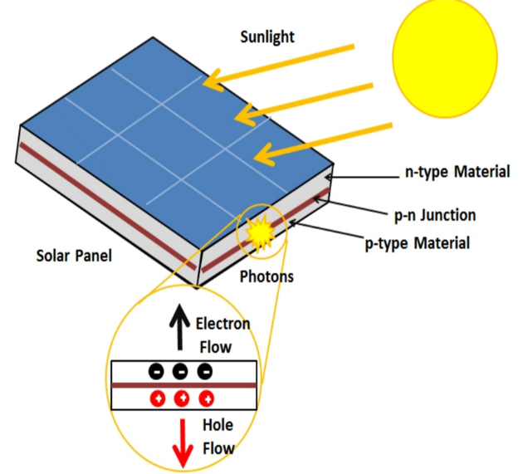
Solar photovoltaic (PV) modules are the fundamental components of solar energy systems, responsible for converting sunlight directly into electrical energy. As shown in the figure 2.1 a PV module consists of multiple photovoltaic cells connected electrically to produce usable direct current (DC) power. These cells are typically made from semiconductor materials such as silicon, which generate electricity through the photovoltaic effect when exposed to solar radiation. The performance of PV modules depends on factors such as solar irradiance, temperature, and material efficiency. Due to their scalability and reliability, PV modules are widely used in residential, commercial, and utility-scale energy systems.
Figure 2.1: the conversion of Solar radiation to electricity in PV systems.

  - Inverters
Inverters are essential components in photovoltaic (PV) systems, responsible for converting the direct current (DC) generated by solar modules into alternating current (AC) suitable for household appliances and grid integration. They also perform additional functions such as maximum power point tracking (MPPT) to optimize energy extraction, system monitoring, and protection against faults. Different types of inverters are used in residential systems, including string inverters, microinverters, and hybrid inverters, each offering specific advantages in terms of efficiency, flexibility, and cost. The overall performance of a PV system is significantly influenced by inverter efficiency and proper sizing.

  - Battery Storge Systems
Battery storage systems play a crucial role in photovoltaic (PV) applications by storing excess energy generated during periods of high solar irradiance for later use. This is particularly important in residential systems where energy demand often peaks during the evening when solar generation is low or unavailable. Batteries enhance system reliability, increase self-consumption, and provide backup power during grid outages. Common battery technologies include lead-acid and lithium-ion, with lithium-ion batteries being more widely adopted due to their higher energy density, longer lifespan, and better efficiency. However, battery integration increases system cost and requires careful sizing and management to ensure optimal performance and longevity.
  - Grid Connection and Net Metering
Grid connection enables photovoltaic (PV) systems to operate in coordination with the utility network, allowing households to draw electricity when solar generation is insufficient and export excess energy when production exceeds demand. Net metering is a billing mechanism that credits PV system owners for the surplus electricity they feed into the grid, effectively reducing their electricity bills. This approach improves the economic viability of residential PV systems by maximizing energy utilization and minimizing waste. However, the effectiveness of grid-connected systems and net metering policies depends on local regulations, tariff structures, and grid infrastructure conditions.

- Designing and Planning of Residential Solar Systems
  - Load Assessment and Energy Consumption Analysis
Load assessment is a fundamental step in designing residential solar energy systems, as it determines the total energy demand and helps in selecting appropriate system components. It involves analyzing the daily energy consumption pattern, identifying peak load periods, and understanding how energy usage varies throughout the day. Accurate load assessment ensures optimal system sizing and improves overall system efficiency and reliability.

The experimental data collected over several days, including temperature, wind speed, voltage, current, and power output, are presented in Table

Date | Time of Day | Temperature (°C) | Wind (km/h) | Pmax (Wp) | Voc (V) | Isc (A) | Vmp (V) | Imp (A)
12-2-2026 | Morning | 11 | 12 | 35.3 | 46 | 0.8 | 44.2 | 0.8
 | Midday | 15 | 14 | 185.2 | 47.7 | 4 | 46.3 | 4
 | Afternoon | 16 | 16 | 661.3 | 46.6 | 16.7 | 39.6 | 16.7
13-2-2026 | Morning | 10 | 3.6 | 569 | 46.7 | 12 | 39.7 | 14.33
 | Midday | 14 | 6 | 601 | 47.3 | 12.7 | 40 | 14
 | Afternoon | 19 | 6 | 709.6 | 45.2 | 15.7 | 38.4 | 15
14-2-2026 | Morning | 11 | 2 | 246 | 47.4 | 5.2 | 38.5 | 4
 | Midday | 14 | 4 | 191 | 45.7 | 4.2 | 38.8 | 5
 | Afternoon | 13 | 6 | 199.87 | 46.7 | 4.2 | 39.7 | 5
15-2-2026 | Morning | 10 | 7 | 650 | 47.4 | 16.4 | 41.7 | 15
 | Midday | 14 | 10 | 584 | 46.2 | 15 | 40.6 | 14.4
 | Afternoon | 10 | 10 | 540 | 45.5 | 14 | 40 | 13.5
16-2-2026 | Morning | 12 | 18 | 600 | 46.4 | 15.4 | 40.8 | 14.7
 | Midday | 14 | 25 | 702 | 47.4 | 17.5 | 41.8 | 16.8
 | Afternoon | 16 | 13 | 560 | 45.8 | 14.6 | 40.3 | 13.9
13-4-2026 | Morning | 14 | 16 | 643 | 47.45 | 17 | 41.7 | 14.5
 | Midday | 15 | 18 | 832.4 | 47.15 | 22 | 41.9 | 19.83
 | Afternoon | 6 | 21 | 155 | 45 | 4.3 | 38.3 | 4
13-4-2026 | Morning | 13 | 6 | 402.2 | 46.75 | 10 | 42.3 | 9.5
 | Midday | 15 | 5 | 622.4 | 46.2 | 15.4 | 42.23 | 14.7
 | Afternoon | 15 | 5 | 602.3 | 46.3 | 16 | 39.59 | 15.15

Morning | Midday | Afternoon
35.3 | 185.2 | 661.3
569 | 601 | 709.6
246 | 191 | 199.87
650 | 584 | 540
600 | 702 | 560
643 | 832.4 | 155
402.2 | 622.4 | 602.3
Table 1: Measured PV system parameters under different environmental conditions

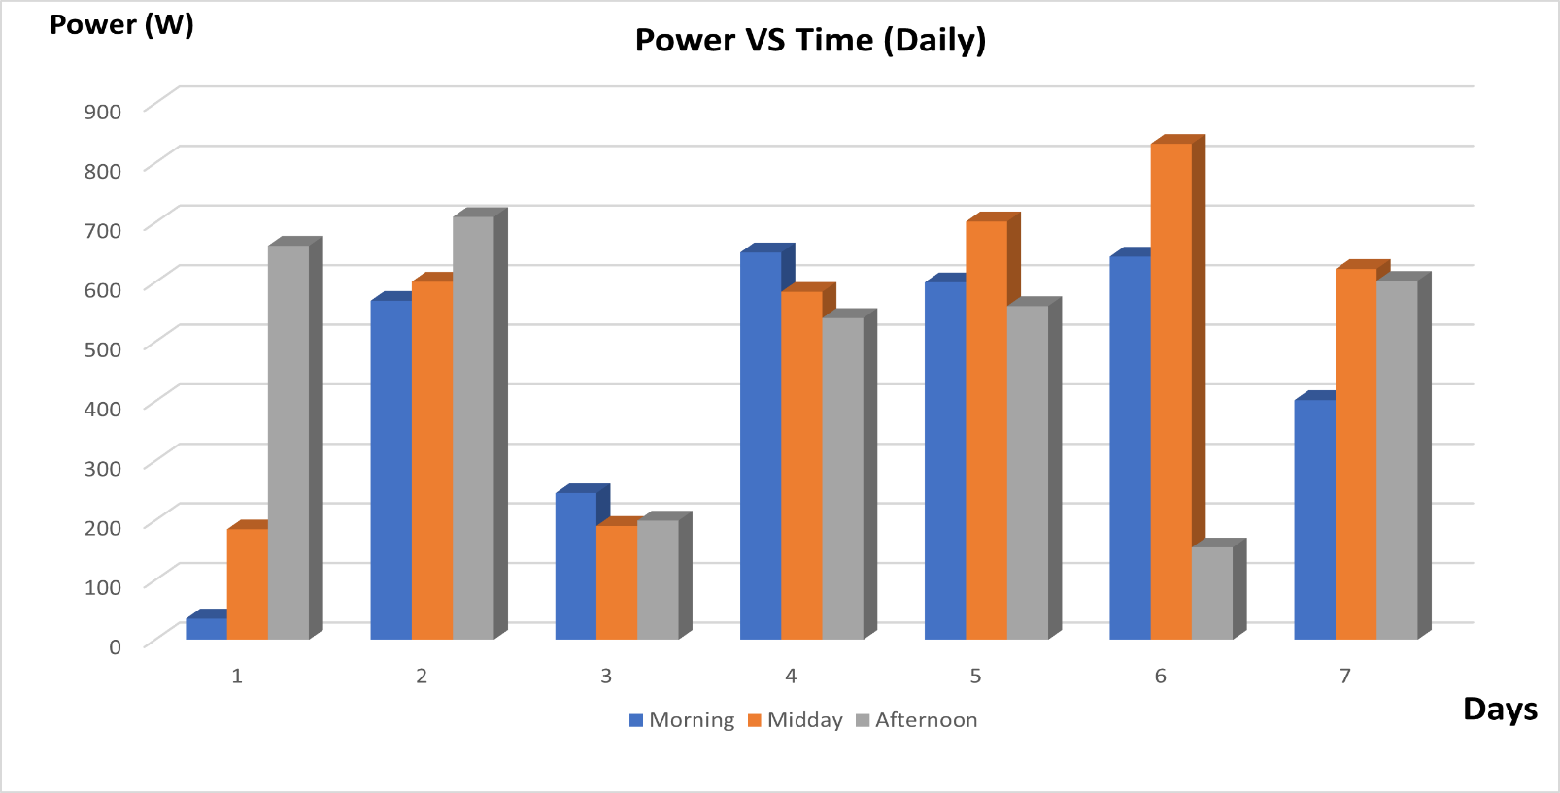 Figure 1: Daily variation of PV power output during morning, midday, and afternoon over seven consecutive days.
As shown in Figure 1, the PV power output varies significantly throughout the day. The highest power levels are generally observed during midday due to peak solar irradiance, while lower values are recorded in the morning and late afternoon. This variation highlights the importance of load assessment to ensure proper matching between energy production and consumption patterns.
  - Site Analysis and Roof Evaluation
Site analysis and roof evaluation are critical steps in the design of residential solar systems, as they directly affect system performance and energy yield. This process involves assessing the geographical location, solar irradiance levels, shading conditions, roof orientation, and tilt angle. Additionally, the available roof area and structural integrity must be evaluated to ensure safe and efficient installation of PV modules. Proper site assessment helps in minimizing energy losses caused by shading and suboptimal orientation. It also ensures that the solar panels receive maximum sunlight exposure throughout the day, leading to improved system efficiency and reliability.
  - System Sizing and Design Calculation
System sizing is a crucial step in the design of residential solar systems, as it determines the required capacity of the photovoltaic array to meet the energy demand. It involves estimating daily energy consumption, evaluating average power output, and selecting appropriate system components such as PV modules, inverters, and batteries. Proper system sizing ensures optimal performance, reduces energy losses, and guarantees system reliability under varying environmental conditions.
Based on the experimental data shown in Figure 1, the power output varies across different times of the day. The highest values are generally observed during midday and afternoon periods due to higher solar irradiance levels. These variations are used to estimate the average daily energy production, which plays a key role in determining the appropriate system size.
The total daily energy output can be approximated by summing the power values recorded during morning, midday, and afternoon periods. This estimation provides a practical basis for sizing the PV system according to real measured data rather than theoretical assumptions.
The number of required solar panels can be determined by dividing the total required power by the rated power of a single PV module. Additionally, the inverter capacity should be selected to match or slightly exceed the total system capacity to ensure efficient operation.
Proper system sizing prevents both overdesign and under design, which can negatively affect system cost, efficiency, and overall performance.

  - Inverter and Battery Selection
Inverter and battery selection are essential components in the design of residential solar systems, as they directly influence system performance, reliability, and energy management. The inverter is responsible for converting the direct current (DC) generated by the photovoltaic (PV) modules into alternating current (AC) suitable for household use. It also plays a key role in system monitoring and protection.
In residential solar systems, the inverter capacity should be carefully selected to match or slightly exceed the total power output of the PV array. This ensures efficient energy conversion and prevents system overload. Additionally, modern inverters often include Maximum Power Point Tracking (MPPT) technology, which optimizes the power output of the PV system under varying environmental conditions.
Battery storage systems are particularly important in hybrid solar systems. The battery capacity is determined based on the daily energy consumption and the required backup duration.
From a design perspective, if the energy demand during non-sunlight hours is significant, integrating a battery system becomes necessary to ensure energy continuity and system reliability. On the other hand, in on-grid systems, batteries may not be required since excess energy can be exported to the grid.
Proper selection of inverter and battery components enhances system efficiency, improves energy utilization, and ensures stable operation under different load and environmental conditions.
  - Tilt Angle and Orientation Optimization
Tilt angle and orientation are key factors that significantly affect the performance of photovoltaic (PV) systems. The orientation refers to the direction in which the solar panels face, while the tilt angle represents the angle between the panel surface and the horizontal plane. For maximum energy production, solar panels should be oriented toward the south in the northern hemisphere, including regions such as Iraq.
The optimal tilt angle is typically close to the latitude of the installation site, which is approximately 30°–35° for Erbil. This allows the panels to receive maximum solar radiation throughout the year. Adjusting the tilt angle can improve energy capture during specific seasons; for example, a higher tilt angle is more suitable in winter, while a lower angle is preferred in summer.
Proper optimization of tilt and orientation helps maximize solar energy absorption, reduce losses due to poor alignment, and improve overall system efficiency. In practical installations, fixed tilt systems are commonly used due to their simplicity and lower cost, although adjustable systems can provide higher energy yield.
Incorrect tilt angle or orientation can significantly reduce the system’s energy output, even if other components are properly designed.

- Installation of Hybrid and On-grid Systems
  - Installation Requirements
The hybrid solar PV system design combines both grid-connected operation and battery storage to ensure continuous and reliable power supply for residential applications. In this system, solar panels generate electricity during daylight hours, which is first used to meet the household load demand. Any excess energy is either stored in the battery system or exported to the grid, depending on system configuration and load requirements.
During periods of low solar generation, such as nighttime or cloudy conditions, the system automatically switches to battery storage or draws power from the grid. This dual functionality enhances system reliability and energy independence. The inclusion of a hybrid inverter allows seamless energy management between solar panels, batteries, and the utility grid.
Based on the analyzed data, the hybrid system is designed to optimize energy utilization by storing surplus midday power for later use, especially during peak demand periods in the evening. This reduces dependence on the grid and improves overall system efficiency.

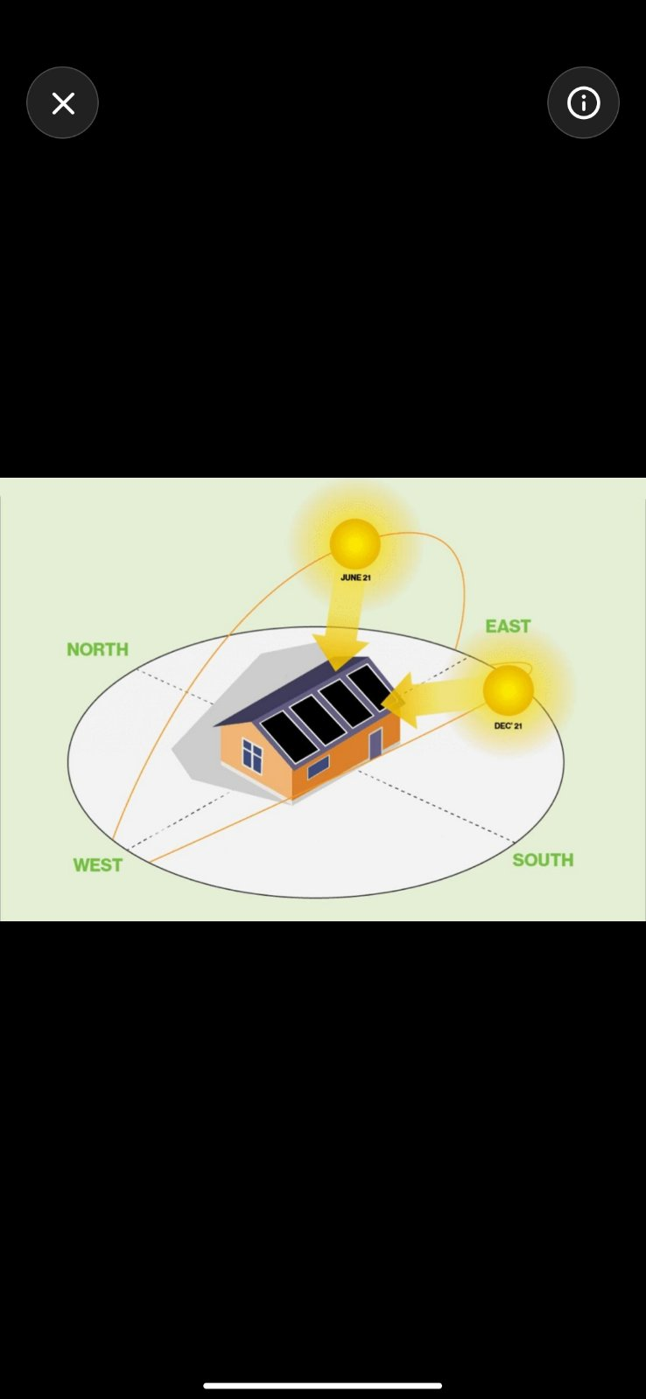Figure 4.1: Typical residential rooftop solar PV installation showing panel arrangement, mounting structure, tilt angle, and exposure to sunlight with minimal shading conditions.

  - Safety Measures and Standards
Safety measures and standards are critical in the installation and operation of residential solar photovoltaic (PV) systems to ensure protection for both users and equipment. Proper electrical protection devices, such as circuit breakers, fuses, and surge protection systems, must be installed to prevent overcurrent, short circuits, and voltage spikes.
Grounding and earthing systems are essential components that protect against electric shock and lightning hazards. All system components, including PV modules, inverters, and metal structures, should be properly grounded according to international standards.
In addition, adherence to recognized standards such as IEC (International Electrotechnical Commission) and NEC (National Electrical Code) is necessary to guarantee safe installation and operation. These standards provide guidelines for wiring, equipment selection, and system protection.
Fire safety is another important aspect, requiring proper cable management, use of fire-resistant materials, and installation of disconnect switches to quickly isolate the system in case of emergency. Regular inspection and maintenance further ensure long-term system safety and reliability.
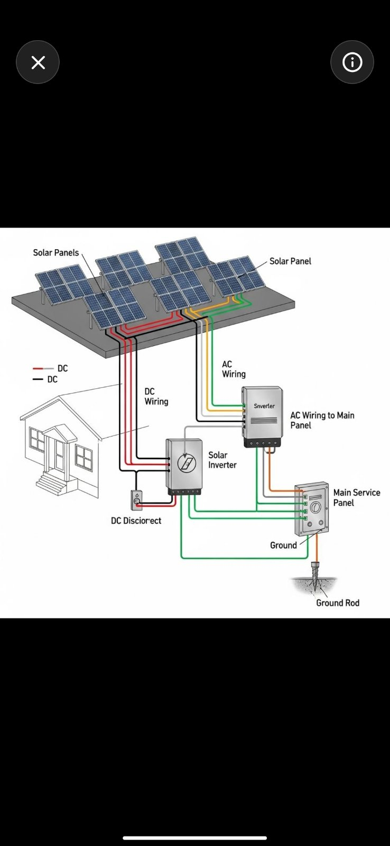Figure 4.2: Safety components in a residential PV system including grounding, protection devices, and emergency disconnect mechanisms.

  - Electrical Wiring and System Connection
Electrical wiring and system connections are essential elements in residential solar photovoltaic (PV) systems, as they ensure efficient energy transfer between system components. The wiring process involves connecting PV modules, inverters, batteries (in hybrid systems), and the utility grid using appropriate cables and protection devices.
Proper cable selection is important to minimize power losses and ensure safe operation. The cables must be sized according to current ratings and system voltage to prevent overheating and voltage drop. In addition, correct wiring configuration, such as series and parallel connections of PV modules, is necessary to achieve the desired voltage and current levels. System connections must also include appropriate protection components, such as disconnect switches and circuit breakers, to allow safe operation and maintenance. In grid-connected and hybrid systems, proper integration between the inverter, battery, and grid is required to ensure smooth power flow and system stability.
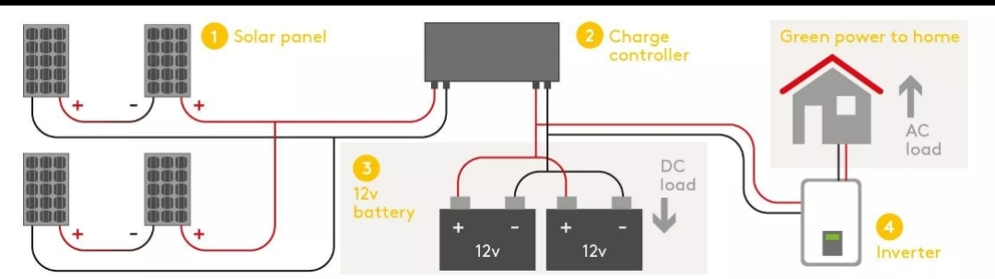
Figure 4.3: Electrical wiring and connections in a residential PV system showing the integration between solar panels, inverter, battery, and load.
  - System Integration and Operation
System integration and operation represent the final stage in the implementation of residential solar photovoltaic (PV) systems, where all components are connected and function together as a unified system. This includes the integration of PV modules, inverter, battery storage (in hybrid systems), and the utility grid to ensure efficient energy flow and system stability. During operation, the system prioritizes the use of solar energy to supply the household load. Excess energy generated during peak solar periods is either stored in the battery or exported to the grid, depending on system configuration. In periods of low solar generation, such as nighttime or cloudy conditions, the system automatically switches to battery storage or grid supply. The inverter plays a central role in managing energy distribution and ensuring smooth transitions between different energy sources. Advanced control systems monitor system performance and optimize energy usage to improve efficiency and reliability.
- Case Study for Residential Applications
  - Description of the Residential Building
The case study is conducted on a residential building equipped with two types of solar photovoltaic (PV) systems: a hybrid system and an on-grid system. The hybrid system includes solar panels, a battery storage unit, and a connection to the utility grid, while the on-grid system consists of solar panels connected directly to the grid without battery storage. Both systems are installed on the rooftop of the building, which provides sufficient space and favorable solar exposure with minimal shading. The purpose of using two different system configurations is to compare their performance under similar environmental and operating conditions. Data were collected over several days, including electrical parameters such as open-circuit voltage (Voc), short-circuit current (Isc), and maximum power output (Pmax), in addition to environmental parameters like temperature and wind speed. Measurements were taken at different times of the day (morning, midday, and afternoon) to analyze the behavior and efficiency of both systems.

  - Load Profile and Power Analysis
The load profile and power behavior of the photovoltaic (PV) system were analyzed based on the variation of output power throughout different times of the day, as illustrated in Figure 2. The results clearly show that the PV power output is highly dependent on solar irradiance availability during the day.
In the morning period, the power output starts at relatively low values due to limited solar radiation, then increases gradually as sunlight intensity improves. Around midday, the system reaches its peak performance, where the highest power values are recorded. This is expected since solar irradiance is at its maximum during this period, leading to optimal energy generation.
In the afternoon, a noticeable decline in power output is observed. This reduction is mainly attributed to the decrease in solar intensity as the sun moves toward the horizon. However, slight fluctuations can be seen in some days, which may be caused by environmental factors such as temperature variations or partial shading.
Overall, the load profile demonstrates a typical daily PV behavior characterized by a rise in power during the morning, a peak at midday, and a gradual decline in the afternoon. This trend confirms that midday is the most critical period for energy production and should be considered in system design and load management strategies, especially in residential applications.
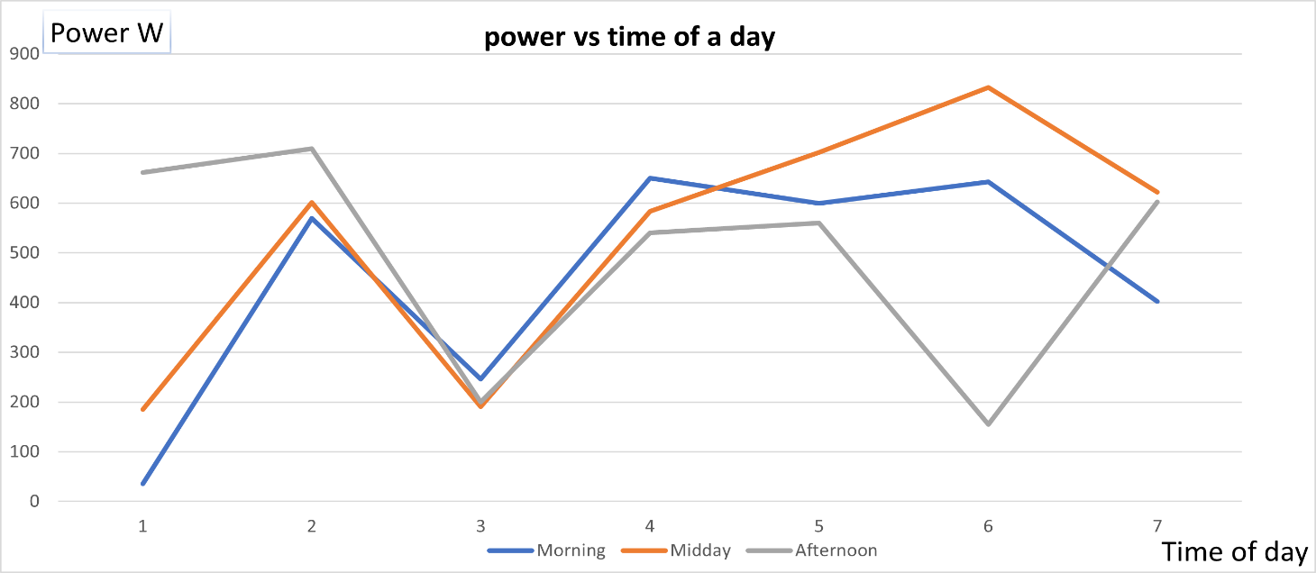
Figure 2: Variation of photovoltaic (PV) power output with time of day (morning, midday, and afternoon) over the observation period, illustrating the daily load profile and peak generation during midday.
  - On-grid System Design
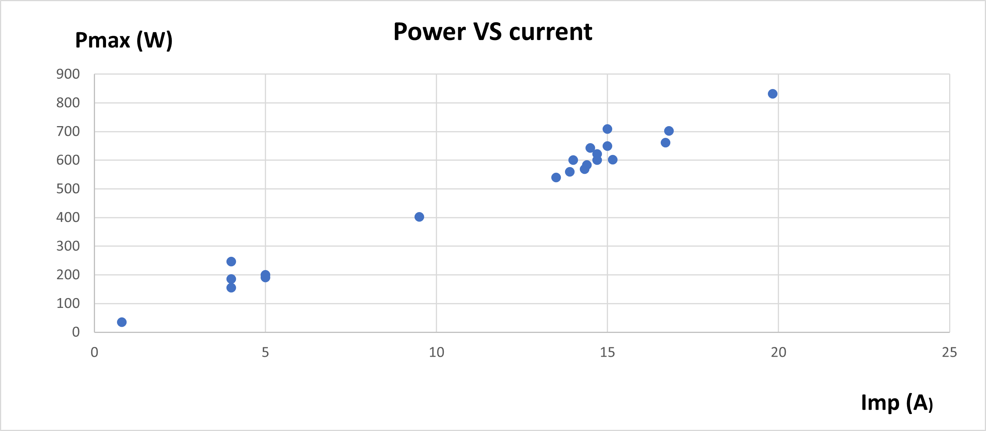
The on-grid photovoltaic (PV) system is designed to operate without battery storage, where the generated power is directly supplied to the residential load and excess energy can be exported to the utility grid. In such systems, the performance strongly depends on the instantaneous electrical characteristics of the PV array, particularly the relationship between current and power.
Figure 3: Relationship between photovoltaic (PV) output power (Pmax) and current (Imp), showing a strong positive correlation and improved performance at higher current levels.

As shown in Figure 3, there is a clear positive correlation between the output power (Pmax) and the current (Imp). The power increases significantly as the current rises, which indicates that the PV system operates efficiently under higher irradiance conditions. This behavior is consistent with the fundamental PV equation P=V*I, where current plays a major role in determining the power output when voltage variations are relatively small.
In the context of on-grid systems, this relationship is critical because the inverter continuously tracks the maximum power point (MPPT) to ensure optimal energy extraction. The clustering of data points at higher current values reflects periods of strong solar irradiance, where the system delivers peak performance and contributes maximum energy to the grid.
Overall, the analysis confirms that current is a key parameter influencing PV power generation in on-grid configurations, and optimizing current flow through proper system design enhances overall efficiency and grid interaction.

  - Hybrid System Design
A hybrid photovoltaic (PV) system combines both on-grid and off-grid functionalities to ensure continuous and reliable power supply. This configuration integrates solar panels with battery storage and grid connection, allowing the system to operate efficiently under varying conditions. During peak solar generation, excess energy is either stored in batteries or exported to the grid, while during low generation periods, the system draws power from the batteries or the grid. The design of the hybrid system is based on the load profile and power analysis presented earlier. The PV array is sized to meet the daytime load demand, while the battery storage is designed to support critical loads during nighttime or grid outages. An inverter with hybrid capability is used to manage energy flow between the PV system, batteries, and the grid, ensuring optimal performance and energy balance. From the analysis of current and power relationships, it is evident that higher current levels contribute to increased power output. Therefore, proper system sizing, including selection of appropriate PV modules, inverter rating, and battery capacity, is essential to maximize system efficiency. Additionally, the integration of a charge controller helps regulate battery charging and prevents overcharging or deep discharge, enhancing battery lifespan. Overall,
Imp (A) | Pmax (Wp)
0.8 | 35.3
4 | 185.2
16.7 | 661.3
14.33 | 569
14 | 601
15 | 709.6
4 | 246
5 | 191
5 | 199.87
15 | 650
14.4 | 584
13.5 | 540
14.7 | 600
16.8 | 702
13.9 | 560
14.5 | 643
19.83 | 832.4
4 | 155
9.5 | 402.2
14.7 | 622.4
15.15 | 602.3
the hybrid system provides flexibility, reliability, and improved energy utilization, making it a suitable solution for areas with unstable grid supply or high energy demand. The hybrid system design is strongly supported by the relationship illustrated in Figure 3, which shows that the PV output power (Pmax) increases with increasing current (Imp). This positive correlation indicates that optimizing current flow is essential for maximizing energy generation. In a hybrid system, this relationship plays a critical role in system performance. During periods of high solar irradiance, the PV system produces higher current, leading to increased power output as demonstrated in Figure 3. This excess power can be efficiently utilized by charging the battery storage or exporting energy to the grid. Conversely, during low irradiance or nighttime, when current and power output decrease, the system relies on stored energy in batteries or imports power from the grid. Therefore, Figure 3 highlights the importance of proper system sizing in hybrid configurations, particularly in selecting suitable PV modules, inverter capacity, and battery storage. Efficient current management ensures optimal energy distribution between generation, storage, and consumption, ultimately improving system reliability and performance.
  - Cost and Performance Comparison
The comparison between on-grid and hybrid photovoltaic (PV) systems highlights significant differences in both cost and performance. On-grid systems are generally more cost-effective due to the absence of battery storage, which reduces the initial investment and maintenance costs. However, their performance is highly dependent on grid availability, making them less reliable in areas with unstable electricity supply. In contrast, hybrid systems involve higher initial costs due to the inclusion of battery storage and additional control components. Despite this, they offer improved reliability and energy independence. The battery allows excess energy generated during peak solar hours to be stored and used during periods of low generation, such as nighttime or cloudy conditions. Based on the experimental data presented earlier (Power vs Time and Power vs Current), hybrid systems demonstrate better utilization of generated energy. For example, during high power output periods (as shown in Figures 2 and 3), excess energy can be stored instead of being lost or exported inefficiently. This leads to improved overall system efficiency and better load management. Furthermore, performance analysis indicates that while on-grid systems achieve high efficiency under stable grid conditions, hybrid systems provide consistent performance regardless of grid fluctuations. The integration of battery storage ensures continuity of supply, which is a critical factor in residential applications.
Overall, although hybrid systems require higher upfront investment, they provide superior performance, reliability, and flexibility, making them a more suitable option for regions with unreliable grid infrastructure.
Feature | On-Grid | Hybrid
Initial Cost | Low | High
Reliability | Medium | High
Battery | No | Yes
Grid Dependency | High | Medium
Energy Storage | No | Yes

- Results and Discussion
  - Performance Evaluation
The performance of the photovoltaic (PV) system was evaluated based on the analysis of power output under different operating conditions. The results indicate that the system performance is strongly influenced by solar irradiance and electrical characteristics, particularly current.
As illustrated in Figure 2, the power output varies significantly throughout the day, with lower values observed during the morning, followed by a gradual increase toward midday, where peak power generation occurs. This behavior is mainly due to the increase in solar irradiance, which directly affects the energy conversion process of the PV modules.
Furthermore, Figure 3 shows a strong positive relationship between current (Imp) and power output (Pmax), confirming that current plays a major role in determining system performance. Higher current values correspond to higher power generation, especially under optimal solar conditions.
Additionally, slight variations in power output were observed across different days, which can be attributed to environmental factors such as temperature and wind speed. These factors influence the efficiency of PV modules and contribute to fluctuations in system performance.
Overall, the PV system demonstrates high performance during peak sunlight hours and reduced efficiency during low irradiance periods. This evaluation highlights the importance of both electrical parameters and environmental conditions in determining the overall efficiency and reliability of residential PV systems.
The system operates most efficiently when both solar irradiance and current levels are high.
  - Energy and Cost Analysis
The energy and cost analysis of the photovoltaic (PV) system was conducted to evaluate the economic feasibility and energy utilization of both on-grid and hybrid configurations. The results indicate that the energy production varies significantly throughout the day, as shown in Figure 2, with peak generation occurring during midday hours due to maximum solar irradiance.
From an energy perspective, the hybrid system demonstrates better energy utilization compared to the on-grid system. This is because excess energy generated during peak periods can be stored in batteries and used later during low generation periods, such as nighttime or cloudy conditions. In contrast, the on-grid system depends entirely on the grid when solar generation is insufficient, which may lead to higher energy costs over time.
In terms of cost, the on-grid system has a lower initial investment since it does not require battery storage. However, its long-term operational cost can be higher due to continuous reliance on the electrical grid. On the other hand, the hybrid system requires a higher upfront cost due to the inclusion of batteries and additional components, but it offers reduced electricity bills and improved energy independence.
Furthermore, the relationship between current and power, as illustrated in Figure 3, supports the efficiency of energy generation. Higher current values correspond to higher power output, which enhances the overall energy yield of the system. This improved energy production can contribute to faster return on investment, particularly in hybrid systems where energy storage is utilized effectively.
Overall, the analysis shows that while on-grid systems are more economical in the short term, hybrid systems provide better long-term benefits in terms of energy efficiency, cost savings, and system reliability.
  - Discussion of Results
The results obtained from the analysis clearly demonstrate the effectiveness of photovoltaic (PV) systems in residential applications. The variation of power output throughout the day, as shown in Figure 2, confirms that solar energy generation is highly dependent on solar irradiance, with peak performance occurring during midday.
Moreover, the relationship between current and power presented in Figure 3 highlights the importance of electrical parameters in determining system efficiency. The strong positive correlation indicates that optimizing current flow is essential for maximizing power output.
The comparison between on-grid and hybrid systems reveals that each configuration has its advantages. On-grid systems are cost-effective and suitable for areas with stable electricity supply, while hybrid systems provide higher reliability and energy independence due to the integration of battery storage.
Additionally, environmental factors such as temperature and wind speed were found to influence system performance, causing variations in power output across different days. This emphasizes the need for proper system design and optimization to ensure consistent performance.
Overall, the findings support the use of hybrid PV systems in regions with unstable grid infrastructure, while on-grid systems remain a practical solution in areas with reliable electricity supply.
- Conclusion
In conclusion, this study investigated the design, performance, and economic aspects of residential photovoltaic (PV) systems, focusing on both on-grid and hybrid configurations. The results demonstrate that PV system performance is significantly influenced by solar irradiance, current, and environmental conditions.
The analysis showed that power output reaches its peak during midday and is directly related to current levels, confirming the importance of electrical parameters in system efficiency. Additionally, the comparison between system types revealed that on-grid systems offer lower initial costs, while hybrid systems provide greater reliability and energy independence.
Although hybrid systems require higher upfront investment, their ability to store energy and reduce dependency on the grid makes them more suitable for long-term applications, especially in areas with unstable power supply.
Therefore, the selection between on-grid and hybrid systems should be based on economic considerations, energy needs, and grid stability. Overall, photovoltaic systems represent a sustainable and effective solution for residential energy generation.
- References

